ATTENTION FISHERS

The Pacific Salmon Commission (PSC), is conducting a radio-tagging study on migrating summer-run Fraser River sockeye in July-October 2005. The purpose of the study is to assess in-river migration behaviour and survival of sockeye salmon caught and released in the lower Fraser River. The proposed research would identify sites and methods that would allow sockeye to be captured, tagged, and released below the Mission hydroacoustic site and determine the survival rates from Mission to spawning areas for all radio-tagged fish. The identification of suitable capture methods (e.g. angling, tooth nets, beach seines) and sites below Mission will lay the groundwork for future survival studies on the Fraser.

Approximately 400 radio tags will be applied to sockeye on the lower Fraser River below Mission, BC. Radio-transmitters will be inserted into the stomach of each fish. Radio-tagged fish will be evident by a thin wire antenna protruding from the mouth and a circular mark on the adipose fin created when the DNA sample was obtained. Radio tagged fish will be tracked from the release site (below Mission) and throughout the watershed as they migrate toward their spawning grounds.

If you catch a radio-tagged sockeye in an open fishery and choose to keep it, please remove the radio tag, record the frequency and code number on the radio tag, time, date and location of capture and contact the tag recovery coordinator at the phone number listed below. If you choose to release the fish or the area is closed for the retention of sockeye, do not attempt to remove the radio tag. Individuals returning radio tags to the project management office at LGL Limited in Sidney BC (address on the tag) along with information on time and place of capture will be sent the complete tracking history of the fish and a small token of appreciation for participating in the study.

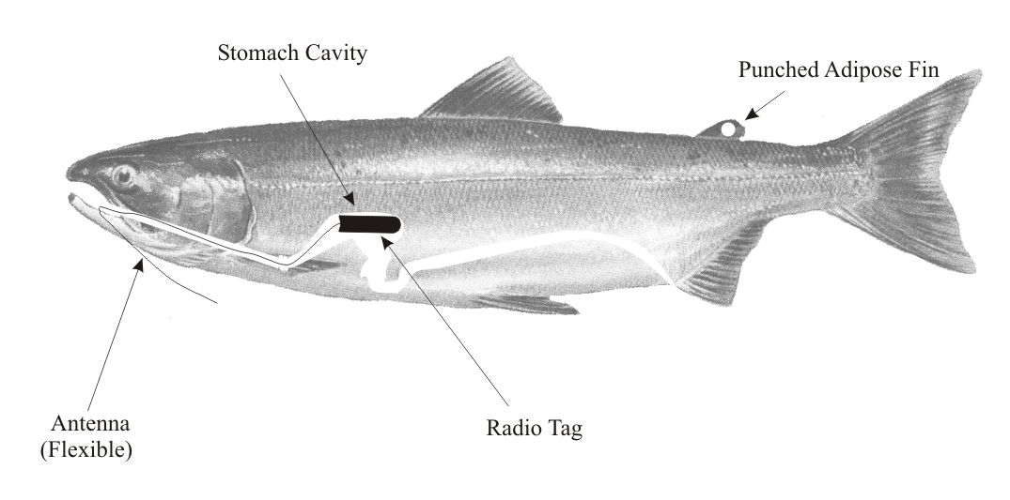

The information obtained through your cooperation in returning these tags will directly contribute to improved management and conservation of Fraser River sockeye. Thank you for your interest and cooperation!

If you catch a radio tagged fish or you have any questions related to this study, please call the following phone number:

Collect (9AM -5PM weekdays): 1-250-656-0127

