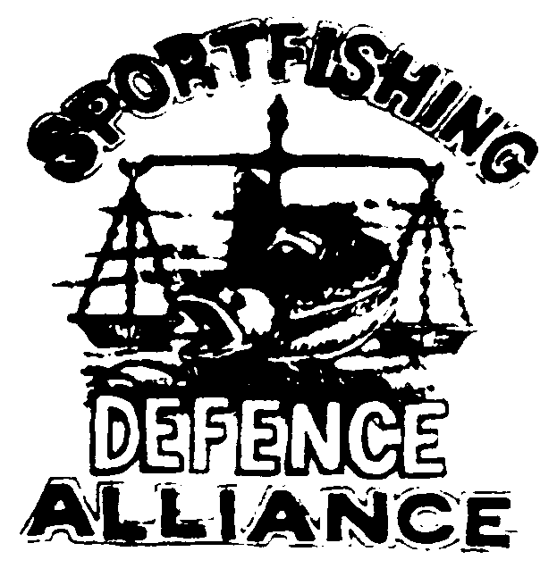
SPORTFISHING
DEFENCE

ALLIANCE
P.O. Box 2477
CHILLIWACK, BC. V2R 1A8
Ph. (250) 378-4489

August 28, 2005

Honourable Geoff Regan, Minister
Fisheries and Oceans Canada
House of Commons
Ottawa, Ontario
K1A 0E6

Dear Mr. Minister

I write to you once again on behalf of my members and the anglers of Canada who are being less than well served by your Department staff here in British Columbia.

The management of the Fraser River Sockeye this present year verges on criminal. Anglers have been denied reasonable access to the resource which has resulted in a much reduced effort and a loss to our industry conservatively estimated at $20 million and putting many on the edge of bankruptcy. In addition of course this same mismanagement has cost B.C. and Canada a minimum of $90 million in economic benefits in the commercial fishery and will actually bankrupt many. A grand total of a minimum $110 million lost through simple incompetence that you have failed to deal with despite the fact this has been pointed out to you ever since you appointment.

In the 36 years and 10 cycles between 1949 and 1985 the average TOTAL escapement to the spawning grounds from this cycle of Fraser River Sockeye was 1,165,739 fish. At the same time the average return from that escapement was 7,288,525 fish and in every one of the years throughout that period we had a successful fishery on those stocks. For the 2005 cycle your staff set the escapement goal for the spawning grounds at 4,654,600 fish. Aside from minor adjustments they have refused to budge from that goal. The end result as we all now know is that there has been no fishing of consequence this year with the exception of First Nations.

Within that escapement goal is one of 401,600 fish applied to the Late Run stocks. This number in spite of the fact that over the past 52 years of this cycle the average escapement to the grounds has been 60,000 fish with the highest recorded being 109,000. Within those late run stocks are the Harrison River stocks. The average return of this stock over the past 52 years on this cycle has been 10,000 fish with the largest ever return shown as 60,000 fish. The latest numbers of this stock currently on the spawning grounds is reported to be 120,000. This stock is the one that has the largest percentage of catch to date within the arbitrarily limiting 15% harvest limit set on these stocks by yourself. Common sense would dictate to anyone who could find their fundamental orifice with both hands, that given this stock is returning at something like 4 times its highest ever escapement, then a 15% exploitation rate should not need to be applied. The 15% rate has however, remained in place.

We could go on Minister, but we hope you have the general idea that a cock up of the highest order has occurred within your Department this current year on the West Coast.

We ask that you move immediately to remove the staff in charge of the management of the Fraser River Sockeye and put them in positions where they can do no more damage to the fishery. We would also strongly request that you move immediately to call for a full and total review of the management of this years Fraser River Sockeye and that you consider providing the needed authority and resources to the Southern Integrated Harvest Management Committee to carry out this task.

I am sure that both the House and Senate committees will be carrying out investigations but we need immediate action to ensure we have a system in place for the 2006 fishery that will ensure rational and sensible management of the stocks.

We await your response.

Bill Otway, President
Sportfishing Defence Alliance
P.O. Box 326 Merritt, B.C.
V1K 1B8
Phone 604 313-7480
E mail waycot@shaw.ca

Cc – Members SDA, SFAB
Cc – Members of Media
Cc – MP’s MLA’s

