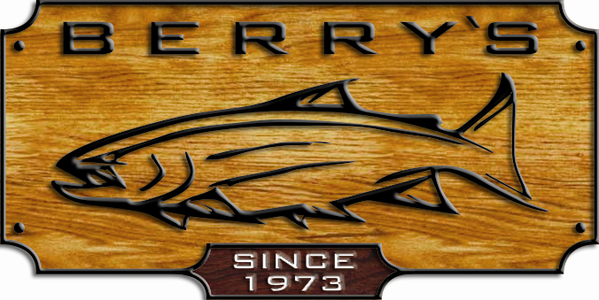
* SCOTTY ROD HOLDERS & MOUNTS

* ALL SALMON NETS * ALL HOOKS

ALL LURES! Many manufacturers - Gibbs , Luhr Jensen , Rhys
Davis, Buzz bomb, Zzinger, Apex, Mepps , Worden’s Flatfish , Lyman ,
Panther Martin, Macdeep, Baitbuster , Baitrix , and many many more !

Saltwater Spinning reels SALE! Saltwater Mooching & trolling reels
Quantum Blue Runner series with Trophy XL “Tyee” anodized machined, cap = 25#/350yds
4 stainless ball bearings! Reg: $ 339.99 SUPER SALE: $ 199.99
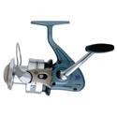
BR50 & BR70 Reg: $ 69.99 Trophy XL QR 4.5 lg. arbor anodized, machined cap= 25# 350 yds
SALE: $ 39.99 Reg: $ 429.99 SUPER SALE: $ 249.99
BR80 Reg: $ 79.99 Penn 320 GT2 cap= 20#/320 yds. Reg: $ 169.99 SALE: $109.99
SALE; $ 49.99 Penn 330 GTi cap=30#/340 yds. Reg: $ 179.99 SALE: $119.99
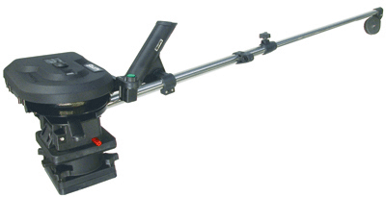

SCOTTY 1106 electric downrigger with Daiwa M-one plus reel Reg: $69.99 ONLY$ 59.99!
60”boom Sug: $ 869.99 SALE:$ 459.99 Quantum MR 5000 Reg: $ 299.99 SALE: $229.99!
SUPER SALE : $ 459.99 SALMON GEAR !

SCOTTY 1099 Electric downrigger with Daiwa Coastal series rods Reg: $ 79.99 SALE: $69.99
24” boom Sug: $ 699.99 SALE: $ 389.99 CLW-SS1102 MHRB 11’ trigger handle 10-20# rating or
CLW-SS1062 MHRB 10’6” trigger handle 10-20# rating
FREE SCOTTY DOWNRIGGER REPAIR Shimano Technium TNC 106M2 10’6” 12-20# rating
CLINIC -SATURDAY JUNE 14TH w/trigger handle Reg: $ 159.99 SUPER SALE: $ 99.99
10 AM TO 3 PM Daiwa CLWM-1062M-G 10’6”mooching rod line rated
15-30 # Reg : $ 59.99 SALE : $ 49.99
JUNE 14 AND JUNE 15 - is FAMILY *NEW* Trophy Royale Sturgeon rod TR580C 8’ 40-80#
FISHING WEEKEND! line rating . Reg: $ 159.99 SALE : $ 99.99
No licence is required for freshwater fishing
Take your family fishing & come out & participate
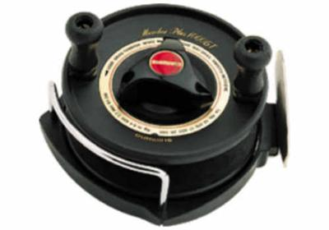
in our Family fishing event… SAT. ONLY –
KIDS LEARN TO CAST & CASTING FUN!
FROM 10 AM TO 2 PM! LOTS OF PRIZES!

ROD & REEL COMBOS !
Berkley HS92F-106 10’6”10-20 # /Quantum 1430/MG Thunder stick ST20TR 86H2 8’6” rod + Sounion
Reg : $ 259.99 WOW !!! NOW $ 159.99 304W reel Reg: $ 219.99 - HOT DEAL ...$ 99.99
Fenwick CMST 1062M 10’6” rod + Abu BCX6000 Daiwa M1 plus /CLWM-1062MG 10’6” mooching rod
( 4 bb + FREE LINE!) Reg: 261.99 SALE: $ 99.99 Reg : $ 149.99 SALE: $ 99.99
Sturgeon / Halibut – Penn 330 Gti + Trophy XL Zebco RNC90DRT 9’ rod & MCR3000 reel
TSS 565 C 6’6” rod Reg: $ 243.99 SALE: $ 169.99 Reg: $ 119.99 SALE: $ 84.99

******FREE HOT DOGS AND DRINKS SATURDAY AND SUNDAY! ******
BERRY’S BAIT & TACKLE… YOUR ONE STOP TACKLE SHOP!
14651 WESTMINSTER HWY. RMD. 604-273-5901 EMAIL: BERRY@BERRYSBAIT.COM
SALE HOURS: MON-THURS. & SAT. 8am to 6pm FRI 8am – 9pm SUN 9am -5pm

100’s MORE SALE ITEMS - TOO MANY TO LIST- AVAILABLE ONLINE TOO!

