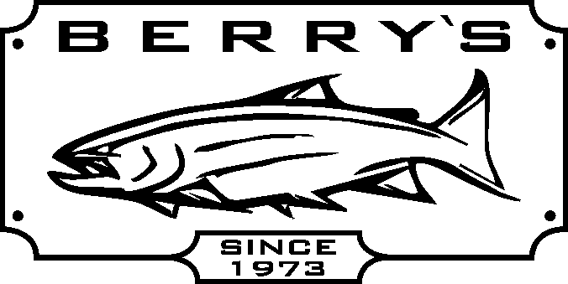
Buy any Outcast pontoon boat & receive a seat saddle bag
FREE! Value: $43.99 - view boats online for more sale prices at
WWW.BERRYSBAIT.COM

DISCOVERY 10 IR – 10’-12 pc alum. frame, padded seat, 7’ oars
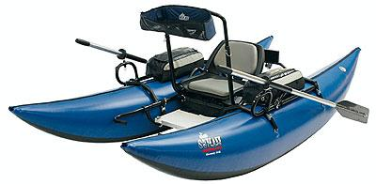
Casting platform / lean bar / stripping apron – load to 450#
Suggested at $ 1399.99 now only …
SAVE $400.00!

DISCOVERY 9 IR - 9’-6 pc alum. frame, padded seat, load to 400 #
Suggested at $ 1099.99 now only ……

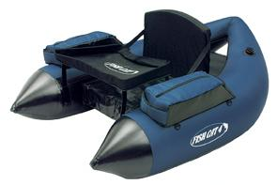
V-BOATS
FISH CAT 4 LCS- with foam seat, load to 250 lbs
Reg: $ 299.99 SALE PRICE: $ 189.99
FISH CAT DELUXE 4 LCS – with air bladder for seat,
and backrest load to 275 #
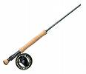
Reg: $ 369.99 SALE PRICE: $ 249.99

Dragonfly rod and reel combo Dragonfly graphite fly rods- DFW 9’ #3-9 weights
DFW95 9’#5 or DFW96 #6 wt rod plus with FREE rod bag & cordura covered rod tube
Kamloops Cassette reel DK5/6 Comes with Reg: $ 109.99 SALE: $ 79.99!
FREE spare cassette & rod case. Reg: $ 179.99
Dragonfly Classic Spey Combo
SALE: 13’ graphite 4 pc rod # 8/9 wt Dragonfly
Machined spey reel with counter balanced
spool, gold & silver anodizing w/ FREE
rod case Reg : $ 699.99

AIRFLO- Northwest 2 handed SKAGIT HEAD FENWICK fly rod/ reel combo – includes HMXF906
PRICED TO CLEAR! 6/7, 7/8 OR 9/10 only! 9’ #6 wt fly rod + Blackhawk disc drag reel, fly line,
Reg: $ 79.99 SALE: $ 39.99! & cordura covered fly rod/reel case SAVE: $ 160.00!
( includes leader wallet & 200 grain tip) Sug: $ 359.99 SALE: $199.99!

Dragonfly Venture DV906 9’#6 wt fly rod +Angler AF56 fly reel Reg: $ 99.99 SUPER PRICE! $ 49.99!

SPINNING COMBOS - many more to see !!

Daiwa DSC-30-3B + DSF 702M 7’medium Quantum – Optix 60 combo – OPS 802M 8’medium
action rod 6-14# test, reel cap.=10#/200yds action rod 15-30# test , reel cap=15#/220 yds w/spare spool
Reg: $ 49.99 SALE: $ 29.99! Reg: $ 59.99 SALE: $ 49.99

Quantum Classic levelwind reel 1430/1431(left) 1pc Berkley Hardrock HS92F-106 10’6” rod + Quantum
aluminum frame 4 stainless bearings, line cap 20#/ 1430 levelwind reel. Reg: 259.99 SALE: $ 159.99
175 yds. Reg: $ 169.99 SALE: $ 119.99 SAVE: $ 100.00! A great casting combo!

Fenwick Methods CMST 1062M 10’6” rod with Abu BCX 6000 4 ball bearing levelwind reel + FREE line
(190 yards of 20# test pre-selected) Reg: $ 261.99 SALE: $ 159.99! SAVE: $ 100.00!

